

**Homework # 6**

**01286121 Computer Programming**

**Software Engineering Program,**

**Department of Computer Engineering,**

**School of Engineering, KMITL**

By

65011693 Soe Moe Htet

No.1

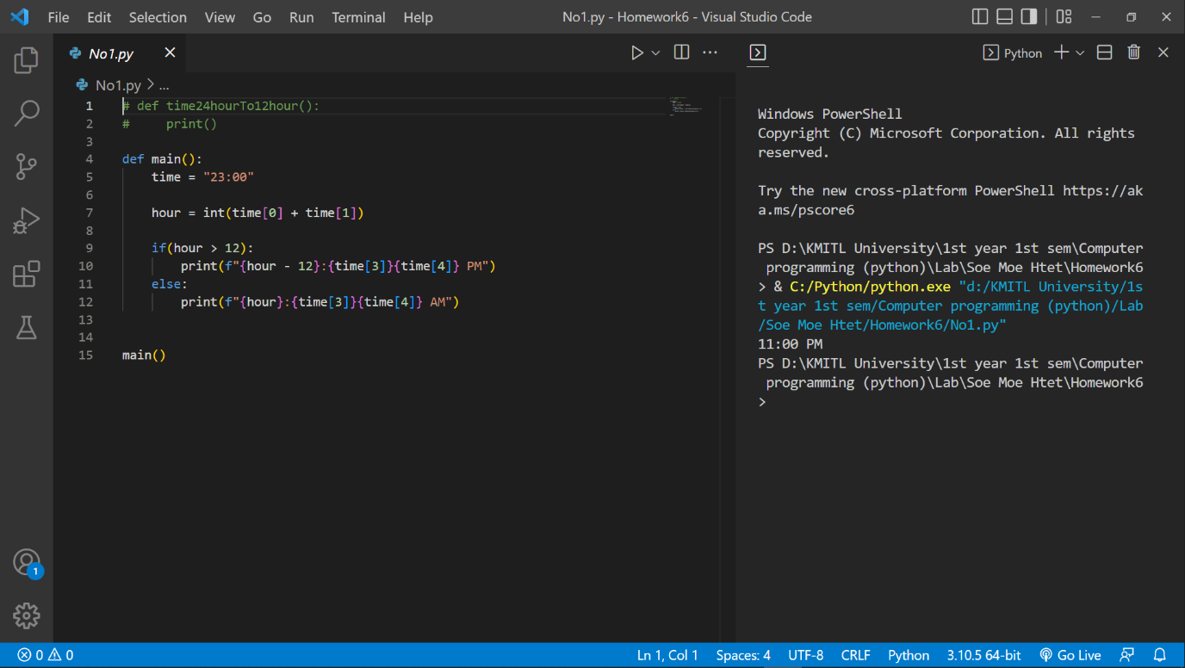

No.2

Code

import turtle as t

win_width, win_height, bg_color = 2000, 2000, 'white'

t.setup()

t.screensize(win_width, win_height, bg_color)

t.speed(0)

arr = ["Mo","Tu","We","Th","Fr","Sa","Su"]

arr1 =['January', 'February', 'March', 'April', 'May', 'June', 'July', 'August', 'September', 'October', 'November', 'December']

def month(month_no, startDay, numberOfDays, a = 6, b = 7 ):

    #tile

    for _ in range(2):

        t.fd(280)

        t.right(90)

        t.fd(20)

        t.right(90)

    t.right(90)

    t.fd(20)

    t.left(90)

    t.write(f"                       \t {arr1[month_no-1]} 2022        ", align="left")

    #Heading

    for cols in range(len(arr)):

        for i in range(2):

            t.fd(40)

            t.right(90)

            t.fd(20)

            t.right(90)

        #table contents

        t.penup()

        t.right(45)

        t.fd(25)

        t.left(45)

        t.pendown()

        t.write(arr[cols])

        t.penup()

        t.right(45)

        t.fd(-25)

        t.left(45)

        t.pendown()

        # end

        t.fd(40)

    t.fd(-280)

    t.penup()

    t.right(90)

    t.fd(20)

    t.left(90)

    t.pendown()

    c = 0

    day = 0

    for _ in range(a):

        for cols in range(b):

            for i in range(2):

                t.fd(40)

                t.right(90)

                t.fd(20)

                t.right(90)

            c+=1

            if c >= startDay and c<=numberOfDays:

                day+=1

                t.penup()

                t.right(45)

                t.fd(25)

                t.left(45)

                t.pendown()

                t.write(day)

                t.penup()

                t.right(45)

                t.fd(-25)

                t.left(45)

                t.pendown()

            t.fd(40)

        t.fd(-280)

        t.penup()

        t.right(90)

        t.fd(20)

        t.left(90)

        t.pendown()

def draw_month(x, y):

    t.penup()

    t.goto(x, y)

    t.pendown()

def calendar_of_2022(number):

    if(number == 1):

        draw_month(-750,350)

        month(1,6,36)

    elif(number == 2):

        draw_month(-750,90)

        month(2,2,29, a = 5, b = 7 )

    elif(number == 3):

        draw_month(-750,-170)

        month(3,2,32, a = 5, b = 7 )

    elif(number == 4):

        draw_month(-400,350)

        month(4,5,34, a = 5, b = 7 )

    elif(number == 5):

        draw_month(-400,90)

        month(5,0,30, a = 5, b = 7 )

    elif(number == 6):

        draw_month(-400,-170)

        month(6,3,32, a = 5, b = 7 )

    elif(number == 7):

        draw_month(-50,350)

        month(7,5,35)

    elif(number == 8):

        draw_month(-50,90)

        month(8,1,31, a = 5, b = 7 )

    elif(number == 9):

        draw_month(-50,-170)

        month(9,4,33, a = 5, b = 7 )

    elif(number == 10):

        draw_month(300,350)

        month(10,6,36)

    elif(number == 11):

        draw_month(300,90)

        month(11,2,31, a = 5, b = 7 )

    elif(number == 12):

        draw_month(300,-170)

        month(12,4,34, a = 5, b = 7 )

def main():

    calendar_of_2022(12)

    t.done()

main()

Output

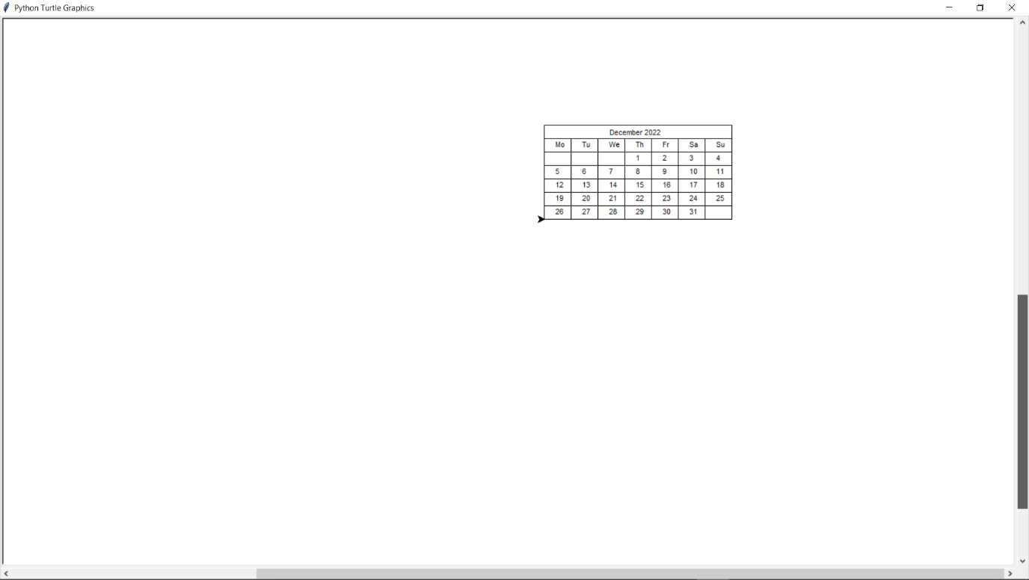

No.4

Code

def main():

    start = input("Type anything if you wanna start. Enter n or space if you don't want to start the program: ")

    if(start!= "n"):

        while(start != ' '):

            original_number = int(input("Enter a number: "))

            original_number = int(original_number)

            arr1 = ["one","two","three","four","five","six","seven","eight","nine"]

            arr2 = ["ten", "eleven","twelve","thirteen","fourteen","fifteen", "sixteen","seventeen","eighteen","ninteen"]

            arr3 = ["twenty","thirty","forty","fifty","sixty","seventy","eighty","ninety"]

            #print(123 // 100, 123//10, 123 /100, 123/ 10, 123 % 10, 123 % 100)

            # 1 12 1.23 12.3 3 23

            #1 // 10, 1/10, 1%10)

            # 0         0.1     1

            number = original_number

            if(original_number == 0):

                print("Zero")

            elif (number >= 0 and number < 100):

                second_digit = number % 10

                number = number // 10

                first_digit = number % 10

                # print(first_digit, second_digit)

                if(original_number > 0 and original_number < 10):

                    print(f"{arr1[original_number-1]}")

                elif(original_number>= 10 and original_number < 20):

                    print(f"{arr2[second_digit]}")

                elif(second_digit == 0):

                    print(f"{arr3[first_digit-2]}")

                else:

                    print(f"{arr3[first_digit-2]}-{arr1[second_digit-1]}")

            elif (number >=0 and number < 1000):

                third_digit = number % 10

                number = number // 10

                second_digit = number % 10

                number = number // 10

                first_digit = number % 10

                last_two_digits = second_digit * 10 + third_digit

                # print(first_digit, second_digit, third_digit)

                if(second_digit == 0 and third_digit == 0):

                    print(f"{arr1[first_digit-1]} hundred")

                elif(original_number % 100 > 0 and original_number % 100 < 10):

                    print(f"{arr1[first_digit-1]} hundred and {arr1[third_digit-1]}")

                elif(original_number % 100 >= 10 and original_number % 100 < 20):

                    print(f"{arr1[first_digit-1]} hundred and {arr2[third_digit]}")

                elif(last_two_digits % 10 == 0):

                    print(f"{arr1[first_digit-1]} hundred and {arr3[second_digit-2]}")

                elif(last_two_digits > 19 and last_two_digits < 100):

                    print(f"{arr1[first_digit-1]} hundred and {arr3[second_digit-2]}-{arr1[third_digit-1]}")

                elif(last_two_digits == 00):

                    print(f"{arr1[first_digit-1]} hundred")

            else:

                print("I don't know")

            start = input("")

main()

Sample output

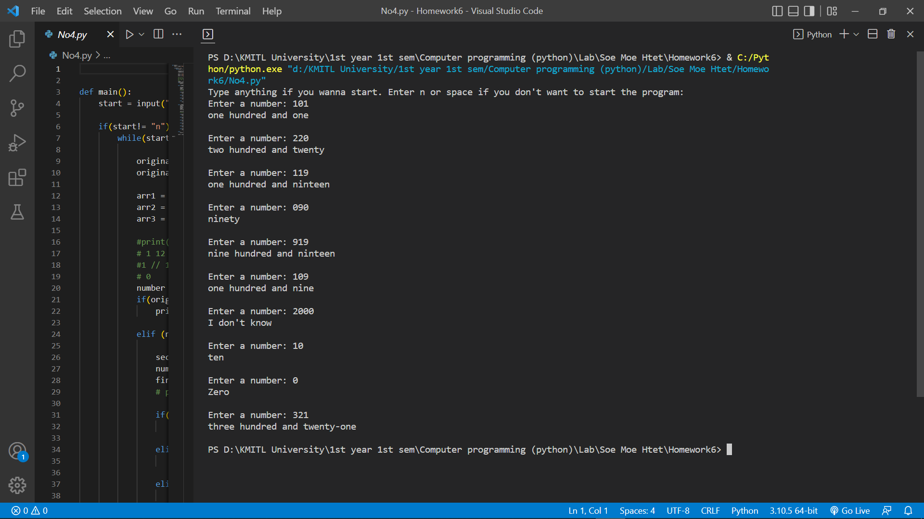

No.5

Code

#print(123 // 100, 123//10, 123 /100, 123/ 10, 123 % 10, 123 % 100)

            # 1 12 1.23 12.3 3 23

            #1 // 10, 1/10, 1%10)

            # 0         0.1     1

def bank_Notes(amount):

    if(amount >= 1000):

        print("1000-Bath notes: ",amount // 1000)

        amount = amount - (amount // 1000) * 1000

    if(amount >= 500):

        print("500-Bath notes: ",amount // 500)

        amount = amount - (amount // 500) * 500

    if(amount >= 100):

        print("100-Bath notes: ",amount // 100)

        amount = amount - (amount // 100) * 100

    if(amount >= 50):

        print("50-Bath notes: ", amount // 50)

        amount = amount - (amount // 50) * 50

    if(amount >= 20):

        print("20-Bath notes: ", amount // 20)

        amount = amount - (amount // 20) * 20

    if(amount >= 10):

        print("10-Bath notes: ", amount // 10)

        amount = amount - (amount // 10) * 10

    if(amount >= 5):

        print("5-Bath notes: ", amount // 5)

        amount = amount - (amount // 5) * 5

    if(amount >= 2):

        print("2-Bath notes: ", amount // 2)

        amount = amount - (amount // 2) * 2

    if(amount >= 1):

        print("1-Bath notes: ", amount // 1)

        amount = amount - (amount // 1)

def main():

    input_amount = int(input("Input your amount of money: "))

    bank_Notes(input_amount)

main()

Sample output

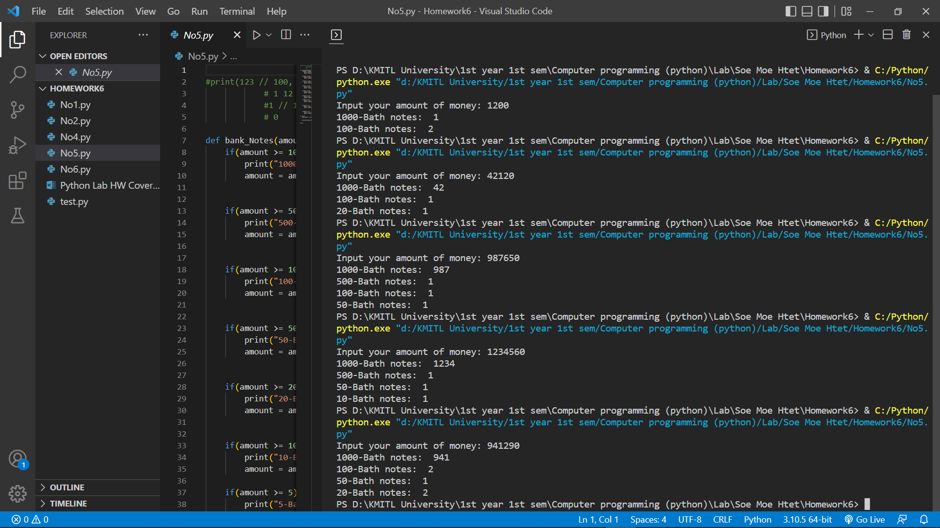

No.6

